MRHC Financial Assistance Application Form and Instructions

This is an application for financial assistance (also known as charity care) at Magnolia Regional Health Center

Mississippi requires all hospitals to provide financial assistance to people and families who meet certain income requirements. You may qualify for free care or reduced-price care based on your family size and income, even if you have health insurance.
What does financial assistance cover? The hospital financial assistance covers appropriate hospital-based services provided by Magnolia Regional Health Center depending upon your eligibility. Financial assistance may not cover all health care costs, including services provided by other organizations.

If you have questions or need help completing this application: Please contact Linda Wood @ lwood@mrhc.org (662-293-1151) or Carol Sells @ csells@mrhc.org (662-293-1078). You may obtain help for any reason, including disability and language assistance.

In order for your application to be processed, you must:
□ | Provide us information about your family  Fill in the number of family members in your household (family includes people related by birth, marriage, or adoption who live together)
□ | Provide us information about your family’s gross monthly income (income before taxes and deductions)
□ | Provide documentation for family income and declare assets
□ | Please enclose a complete copy of your most recent Federal Income Tax Return and W2 forms.
□ | Attach additional information if needed
□ | Sign and date the form
Note: You do not have to provide a Social Security number to apply for financial assistance. If you provide us with your Social Security number, it will help speed up processing of your application. Social Security numbers are used to verify information provided to us. If you do not have a Social Security number, please mark “not applicable” or “NA.”

INCOME INFORMATION
REMEMBER: You must include proof of income with your application.
You must provide information on your family’s income. Income verification is required to determine financial assistance.
All family members 18 years old or older must disclose their income. If you cannot provide documentation, you may submit a written signed statement describing your income. Please provide proof for every identified source of income. Examples of proof of income include:
- A "W-2" withholding statement; or
- Current pay stubs (3 months); or
- Last year’s income tax return, including schedules if applicable; or
- Written, signed statements from employers or others; or
- Approval/denial of eligibility for Medicaid and/or state-funded medical assistance; or
- Approval/denial of eligibility for unemployment compensation.

If you have no proof of income or no income, please attach an additional page with an explanation.

EXPENSE INFORMATION
We use this information to get a more complete picture of your financial situation.
Monthly Household Expenses:
Rent/mortgage $_______________________ Medical expenses $_______________________
Insurance Premiums $_______________________ Utilities $_______________________ Other Debt/Expenses $_______________________ (child support, loans, medications, other)

ASSET INFORMATION
This information may be used if your income is above |  | 101% | of the Federal Poverty Guidelines.
Current checking account balance  $_____________________________  Current savings account balance  $_____________________________ | Does your family have these other assets?  Please check all that apply  □ Stocks □ Bonds □ 401K □ Health Savings Account(s) □ Trust(s)  □ Property (excluding primary residence) □ Own a business
ADDITIONAL INFORMATION
Please attach an additional page if there is other information about your current financial situation that you would like us to know, such as a financial hardship, excessive medical expenses, seasonal or temporary income, or personal loss.

PATIENT AGREEMENT
I understand that Magnolia Regional Health Center may verify information by reviewing credit information and obtaining information from other sources to assist in determining eligibility for financial assistance or payment plans.

I affirm that the above information is true and correct to the best of my knowledge. I understand if the financial information I give is determined to be false, the result may be denial of financial assistance, and I may be responsible for and expected to pay for services provided.
_______________________________________________ ___________________________
Signature of Person Applying Date

HHS POVERTY GUIDELINES FOR 2022
The 2021 poverty guidelines are in effect as of January 13, 2022
The Federal Register notice for the 2022 Poverty Guidelines will be published on February 1, 2022.

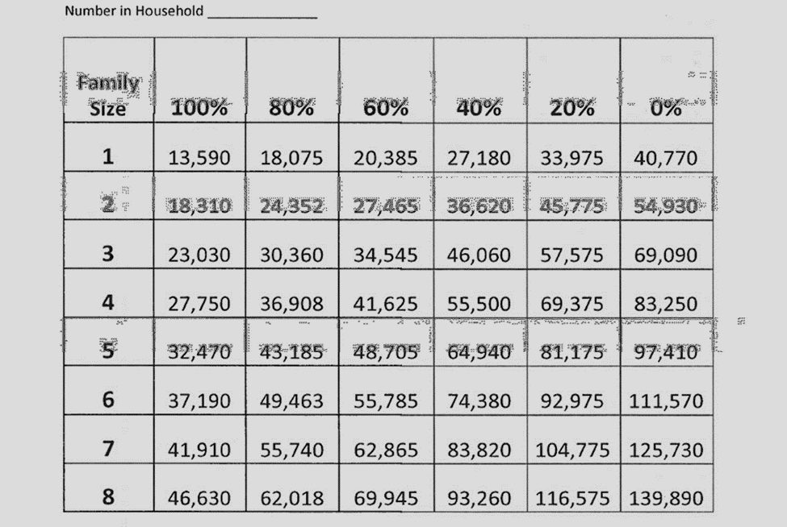
Effective Date: 11/01/2022

