MAGNOLIA REGIONAL HEALTH CENTER
Corinth, Mississippi
Department Policy and Procedure
Patient Financial Assistance Policy
Policy #PFS_505
Patient Financial Services

POLICY
Magnolia Regional Health Center’s Financial Assistance Policy is to provide medically necessary health care services for patients in its service area as defined by MRHC from time to time. The intent of this policy is to provide financial assistance, in accordance with all applicable federal (IRC 501(r)) and state laws, to Hospital patients who are unable to pay for their health care services.

I. PURPOSE
This policy serves to establish and ensure a fair and consistent method for the review and completion of requests for financial assistance to our patients in need.
II. DEFINITIONS
The following definitions are applicable to all sections of this policy:
1. HOSPITAL. Magnolia Regional Health Center.
2. INCOME. Any household income (including spouse/partner), whether from active or passive activities, such as rental, social security, disability, retirement, alimony or child support, unemployment benefits, inheritance, investment, annuity payouts, sale of long-term assets, proceeds from life insurance, third party settlements or lump sum annuity payments, will be considered as income. Noncash benefits (food stamps and housing subsidies) are not considered income.
3. PATIENT MAXIMUM LIABILITY. The amount that the patient’s annual household income exceeds the applicable Federal Poverty Guidelines.
4. FINANCIAL ASSISTANCE GUIDELINES. A matrix is developed annually for determining a patient’s liability for payment of Hospital’s billed charges. This matrix includes the Federal Poverty Guidelines, which are adjusted annually. Included in the matrix is the number of individuals in the household.
5. HOSPITAL’S SERVICE AREA. For Hospital, the four (4) county service area is:
    - Alcorn County:
      - Corinth
      - Kossuth
      - Biggersville
      - Jacinto
      - Glen
      - Farmington
      - Rienzi

    - Tishomingo:
      - Tishomingo
      - Dennis
      - Iuka
      - Golden
      - Burnsville
      - Paden
      - Belmont
    - Prentiss:
      - Booneville
      - Wheeler
      - Jumpertown
      - Marietta
      - New Site
    - Tippah:
      - Ripley
      - Dumas
      - Walnut
      - Blue Mountain
      - Falkner

6. AMOUNTS GENERALLY BILLED (AGB). The AGB is the maximum amount we will collect from a patient who is eligible for financial assistance under our Financial Assistance policy. The AGB percentage is based on all claims allowed by Medicare and private health insurers over a 12-month period, divided by the associated gross charges for those claims. If you have questions about the AGB or how the AGB is calculated, please contact our financial counselor at 662-293-1151
7. CHARITY CARE. Charity Care is a result from provider’s policy to provide health care services free of charge to individuals who meet the established criteria.
8. EXTRAORDINARY COLLECTIONS ACTION (ECAs). Actions taken by a Hospital in an attempt to collect a patient debt that includes credit reporting, wage garnishments, liens on personal property or other civil legal actions.
9. FINANCIAL ASSISTANCE. Financial Assistance is a result from Hospital’s policy to provide health care services at a discount to individuals who meet the established criteria.
10. FAMILY/HOUSEHOLD. Using the Census Bureau definition, a group of two or more people who reside together and who are related by birth, marriage, or adoption. According to Internal Revenue Service rules, if the patient claims someone as a dependent on their income tax return, they may be considered a dependent for purposes of the provision of financial assistance.
11. GROSS CHARGES. The total charges at the Hospital’s full established rates for the provision of patient care services before deductions from revenue or discounts are applied.
12. UNINSURED. The patient has no level of insurance or third-party assistance to assist with meeting his/her payment obligations.

13. UNDERINSURED. The patient has some level of insurance or third-party assistance but still has out-of-pocket expenses that exceed his/her financial abilities.
14. THIRD-PARTY LIABILITY CLAIMS. Any claim a patient may have against another individual, insurer, or entity responsible for covering that patient’s cost of medical services. Emergency Medical Conditions: Defined within the meaning of section 1867 of the Social Security Act (42 U.S.C. 1395dd).
III. FINANCIAL ASSISTANCE
1. Hospital will provide emergency and medically necessary inpatient and outpatient Hospital services (including emergency room services) to patients with household income levels at or below 150% of the federal poverty guidelines free of charge. The amount of eligible charity will be any remaining balance on the account less the patient’s maximum liability. Those above 150% of the federal poverty guidelines are eligible for discounts per the hospital billing and collections policy.
Hospital will provide without discrimination and in compliance with the Emergency Medical Treatment and Active Labor Act (EMTALA) care for emergency medical conditions to individuals regardless of their eligibility for charity care, financial assistance or government assistance. In accordance with EMTALA, emergency and medically necessary care will not be delayed or withheld based on a patient’s ability to pay. Any evaluation of financial arrangements will occur only after an appropriate medical screening examination has occurred and necessary stabilizing services have been provided in accordance with EMTALA and all applicable State and Federal regulations.
2. Hospital’s FAP does not cover charges for patients or treatments in the following situations:

a. The patient has third-party insurance coverage. A discretionary exception may be made for insured patients is the provision for the medically under-insured.
b. The patient’s primary residence is outside the service area.
c. The patient is currently in the custody of a correctional facility.
d. The patient is eligible for financial assistance under another city, county, state, federal or another assistance program which supersedes the FAP.
e. If patient charges resulted from a work-related accident, patients are not eligible to apply unless they can provide proof of no third-party coverage.
f. If patient charges resulted from an auto accident, patients are not eligible to apply unless they can provide proof of no third-party coverage.
3. Hospital’s FAP does not cover charges for the following services: Charges for services by providers who do not participate in the Hospital’s FAP Program are not covered under the FAP. A list of services including, but not limited to, are outside or specialty laboratory services, radiologists, pathologists, ambulance services, non-participating physicians, as well as services provided at facilities that are not owned by Hospital. A list of facilities that are not hospital owned may be found on the Hospital’s website under “Find a Provider.”
4. Hospital’s charity care financial assistance is applicable only to items and services defined as covered items and services for emergency and medically necessary treatment. Covered items and services shall include at a minimum those items and services covered by the Mississippi Medicaid Program that are provided by Hospital.
5. Hospital may direct patients to the most appropriate care settings for the services needed, however, emergent patients will never be directed to non-emergent care settings until patient is stabilized. Hospital may direct non-emergent patients to appropriate care settings where available capacity exists.
6. This policy applies only to individuals residing in the Hospital service area, as defined in the Definitions section of this policy.
7. This policy is not applicable to physicians or their immediate family members
8. This policy applies only to those individuals who cooperate fully with Hospital’s request for information to verify patient’s eligibility, including appropriate identification. It is patient’s responsibility to respond truthfully, promptly, and completely to Hospital’s request for information but in no event more than 240 days from date of first billing statement. In addition, patient’s full cooperation in applying for Medicaid or coverage by other governmental programs is required, if so requested.
IV. PROCEDURE
1. Notice of Hospital’s Financial Assistance Policy.
a. Hospital will post at inpatient and outpatient admission areas notice of its charity care policy.
b. Hospital will make available at inpatient and outpatient admission areas the most currently available poverty guidelines and financial assistance policy and application and, on its web page: (www.mrhc.org) and upon written request to the Business Office at 662-293-1151 to ask questions or have an application mailed to them.
2. Eligibility Criteria. Eligibility for charity care or financial assistance will be considered for those individuals who are uninsured, underinsured, ineligible for any government health care benefit program, and who are unable to pay for their care, based upon a determination of financial need in accordance with this policy. The granting of charity care or financial assistance shall be based on an individualized determination of financial need, and shall not take into account age, gender, race, social or immigrant status, sexual orientation or religious affiliation. The Hospital shall determine whether or not patients are eligible to receive charity or financial assistance for deductibles, coinsurance, or copayment responsibilities.
3. Eligibility Determination.
a. Hospital personnel will provide patients with a copy of its financial assistance policy and an application for financial assistance upon request or once a patient is identified as potentially eligible for financial assistance. A plain language summary will be offered to patients at admission or discharge. The timing of the delivery of this policy and application will depend upon when the identification is made and may be at the time of service, during the billing process, or during collection. The patient must complete the application for charity care and provide the requested information. Hospital personnel will then review the application and supporting information to determine eligibility.
b. It is preferred but not required that a request for a determination of financial assistance occurs prior to rendering of non-emergent medically necessary services. However, the determination may be done at any point in the collection cycle. The need for charity care and financial assistance may be re-evaluated at each subsequent time of services if the last financial evaluation was completed more than a year prior, or as any unusual circumstances arise, relevant to the eligibility of the patient.
c. In evaluating a patient’s need for charity care, Hospital personnel may review the patient’s W-2's (or the responsible party, if spouse, or if a minor is the patient), tax returns, pay stubs, bank statements, written verification of wage from employer and written verification from a public welfare agency, governmental agency, or other information attesting to patient’s income status. Patient shall provide information related to possible third-party liability incidents, total household income and where applicable, including accident reports and copies of vehicle insurance policies. Patient shall supply all documentation reasonably necessary to verify eligibility. Failure to provide all requested information may result in denial of financial assistance.
Financial assistance evaluation may also include:
i. include the use of external public available data sources that provide information on a patient’s or a patient’s guarantor’s ability to pay (such as credit scoring).
ii. reasonable efforts by the Hospital to explore appropriate alternative sources of payment and coverage from public and private payment programs, and to assist patients to apply for such programs.
iii. consider the patient’s available assets and all other financial resources available to the patient.
iv. a review of the patient’s outstanding accounts receivable for prior services rendered and the patient’s payment history.
v. Hospital personnel will use the federal poverty level information matrix most currently available to determine patient’s eligibility to receive financial assistance under this policy.
V. REVIEW AND APPROVAL
1. Each patient must be individually determined to be eligible for financial assistance under the policy. This determination will be made by the Hospital’s Business Office. A patient may request determination of eligibility up to 240 days from the date of the first post discharge billing statement.
2. Hospital shall make every attempt to notify the patient/applicant in writing within thirty (30) days of receipt of a completed application.
3. Based upon other data and information available to Hospital, the Hospital may presumptively assume that patient is eligible for charity care/financial assistance.
4. Charity care financial assistance offered under this policy is subject to review by Hospital’s management and board to ensure compliance with this policy.
VI. EXCEPTIONS
Hospital reserves the right to grant financial assistance in extraordinary circumstances to patients who do not otherwise meet the charity care guidelines. Hospital also reserves the right to deny charity care assistance to patients who fail to cooperate with Hospital’s efforts to verify eligibility, provide false information, refuse to apply (when potentially eligible) for Medicaid or other governmental program benefits, or fail to respond to requests for information within the time required.
VII. SERVICES ELIGIBLE UNDER THIS POLICY
For purposes of this policy, financial assistance refers to health care services provided by the Hospital without charge or at a discount to qualifying patients.
The following health care services are eligible for charity care or financial assistance:
1. Emergency medical services provided in an emergency room setting.
2. Services for a condition which, if not promptly related, would lead to an adverse change in the health status of an individual.
3. Non-elective services provided in response to life threatening circumstances in a non-emergency room setting.
4. Medically necessary services evaluated on a case-by-case basis at Hospital’s discretion utilizing the State of Mississippi Medicaid Program’s determination of medically necessary.
VIII. ELIGIBILITY CRITERIA AND AMOUNTS BILLED TO PATIENTS
Services eligible under this Policy will be made available to the patient on a sliding fee scale, in accordance with financial need, as determined in reference to Federal Poverty Levels (FPL) in effect at the time of the determination.
The basis for the amount the Hospital will charge patients qualifying for assistance is as follows:
1. Patients whose gross family income is at or below 150% (between 0% and 150%) of the FPL are eligible to receive free (charity) healthcare services.
2. Patients whose family gross income is equal to or greater than 200% of the FPL may be eligible to receive discounted rates on a case-by-case basis based on their specific circumstances, such as catastrophic illness or medical indigence, insurance deductible at a high percentage of income, at the discretion of the Hospital. However, the discounted balance shall not be greater than the Hospital’s AGB.
3. Hospital reserves the right to use external scoring systems to predict eligibility for financial assistance. In these cases, Hospital may deem an individual to be eligible for Financial Assistance, including free health care (charity).
IX. RELATIONSHIP TO BILLING AND COLLECTION POLICY
Hospital has a separate billing and collection policy for internal and external collection practices (including actions the Hospital may take in the event of non-payment, including collection actions and reporting to credit agencies) that take into account the extent to which the patient qualifies for charity care or financial assistance, a patient’s good faith effort to apply for a governmental program or for charity from the Hospital, and a patient’s good faith effort to comply with his other payment agreements with the Hospital.

For patients who qualify for charity care or financial assistance and who are cooperating in good faith to resolve their discounted Hospital bills, the Hospital may offer extended payment plans, will not send unpaid bills to outside collection agencies, and will cease all collection efforts. The Hospital will not impose extraordinary collections actions (ECAs) such as credit reporting, wage garnishments, liens on individual’s property, or other civil legal actions for any patient without first making reasonable efforts to determine whether that patient is eligible for charity care or financial assistance under this Policy. A free copy of this policy may be obtained on Hospital’s webpage or by contacting the Hospital’s billing office. Hospital will not engage in ECA before it makes a reasonable effort to determine whether a patient is eligible for financial assistance under this policy.

MRHC Charity Care/Financial Assistance Application Form Instructions

This is an application for financial assistance (also known as charity care) at Magnolia Regional Health Center (MRHC).
Mississippi requires all hospitals to provide financial assistance to people and families who meet certain income requirements. You may qualify for free care or reduced-price care based on your family size and income, even if you have health insurance.
What does financial assistance cover? The hospital financial assistance covers appropriate hospital-based services provided by MRHC depending upon your eligibility. Financial assistance may not cover all health care costs, including services provided by other organizations.
If you have questions or need help completing this application: Please contact Linda Wood @ lwood@mrhc.org (662-293-1151) or Carol Sells @ csells@mrhc.org (662-293-1078). You may obtain help for any reason, including disability and language assistance.

In order for your application to be processed, you must:
□ | Provide us information about your family  Fill in the number of family members in your household (family includes people related by birth, marriage, or adoption who live together)
□ | Provide us information about your family’s gross monthly income (income before taxes and deductions)
□ | Provide documentation for family income and declare assets
□ | Please enclose a complete copy of your most recent Federal Income Tax Return and W2 forms.
□ | Attach additional information if needed
□ | Sign and date the form
Note: You do not have to provide a Social Security number to apply for financial assistance. If you provide us with your Social Security number, it will help speed up processing of your application. Social Security numbers are used to verify information provided to us. If you do not have a Social Security number, please mark “not applicable” or “NA.”
INCOME INFORMATION
REMEMBER: You must include proof of income with your application.
You must provide information on your family’s income. Income verification is required to determine financial assistance.
All family members 18 years old or older must disclose their income. If you cannot provide documentation, you may submit a written signed statement describing your income. Please provide proof for every identified source of income. Examples of proof of income include:
- A "W-2" withholding statement; or
- Current pay stubs (3 months); or
- Last year’s income tax return, including schedules if applicable; or
- Written, signed statements from employers or others; or
- Approval/denial of eligibility for Medicaid and/or state-funded medical assistance; or
- Approval/denial of eligibility for unemployment compensation.

If you have no proof of income or no income, please attach an additional page with an explanation.

EXPENSE INFORMATION
We use this information to get a more complete picture of your financial situation.
Monthly Household Expenses:
Rent/mortgage $_______________________ Medical expenses $_______________________
Insurance Premiums $_______________________ Utilities $_______________________ Other Debt/Expenses $_______________________ (child support, loans, medications, other)

ASSET INFORMATION
This information may be used if your income is above |  | 101% | of the Federal Poverty Guidelines.
Current checking account balance  $_____________________________  Current savings account balance  $_____________________________ | Does your family have these other assets?  Please check all that apply  □ Stocks □ Bonds □ 401K □ Health Savings Account(s) □ Trust(s)  □ Property (excluding primary residence) □ Own a business
ADDITIONAL INFORMATION
Please attach an additional page if there is other information about your current financial situation that you would like us to know, such as a financial hardship, excessive medical expenses, seasonal or temporary income, or personal loss.

PATIENT AGREEMENT
I understand that Magnolia Regional Health Center may verify information by reviewing credit information and obtaining information from other sources to assist in determining eligibility for financial assistance or payment plans.

I affirm that the above information is true and correct to the best of my knowledge. I understand if the financial information I give is determined to be false, the result may be denial of financial assistance, and I may be responsible for and expected to pay for services provided.
_______________________________________________ ___________________________
Signature of Person Applying Date

HHS POVERTY GUIDELINES FOR 2022
The 2021 poverty guidelines are in effect as of January 13, 2022.
The Federal Register notice for the 2022 Poverty Guidelines will be published on February 1, 2022.

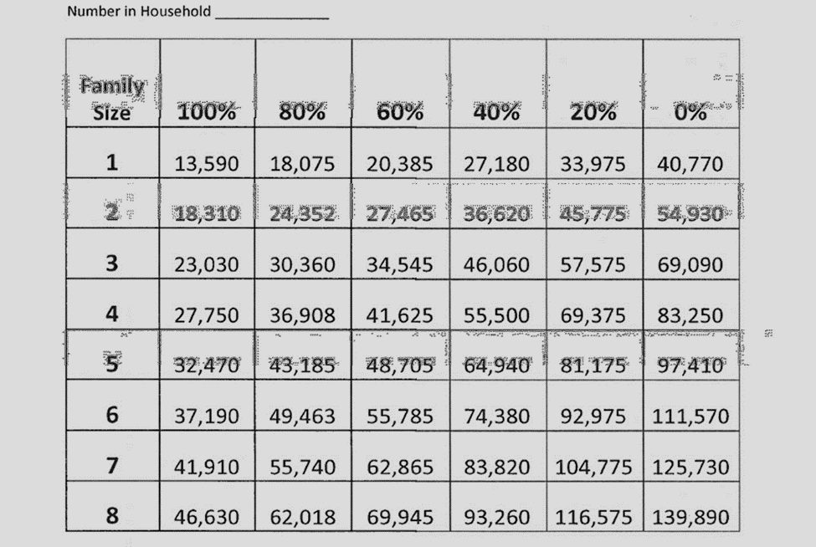
Effective Date: 11/01/2022

